**Homework Sheet # 4** Name:

Parent Signature: Date: Period:

*Show all work* - ***NO CALCULATORS! Due: Thursday 9/25***

**_______________________________________________________________________**

**1.** Place the rational numbers in the appropriate boxes in accordance to the relationship of the numbers.

-6, $\frac{1}{3}$, 0, 2.5, 8

Rational Numbers

Integers

Whole Numbers

**2.** Circle the following numbers that are integers?

8, 1.22, -16, $\frac{9}{3}$, 0

**3.** Tara says -6 is a rational number and an integer but not a whole number. John says -6 is a rational number, integer and whole number. Which student is correct?

**4.** What is the absolute value of -25?

**5.** Find the sum of -7 + 8

**6.** Which statement is true about the number line shown?

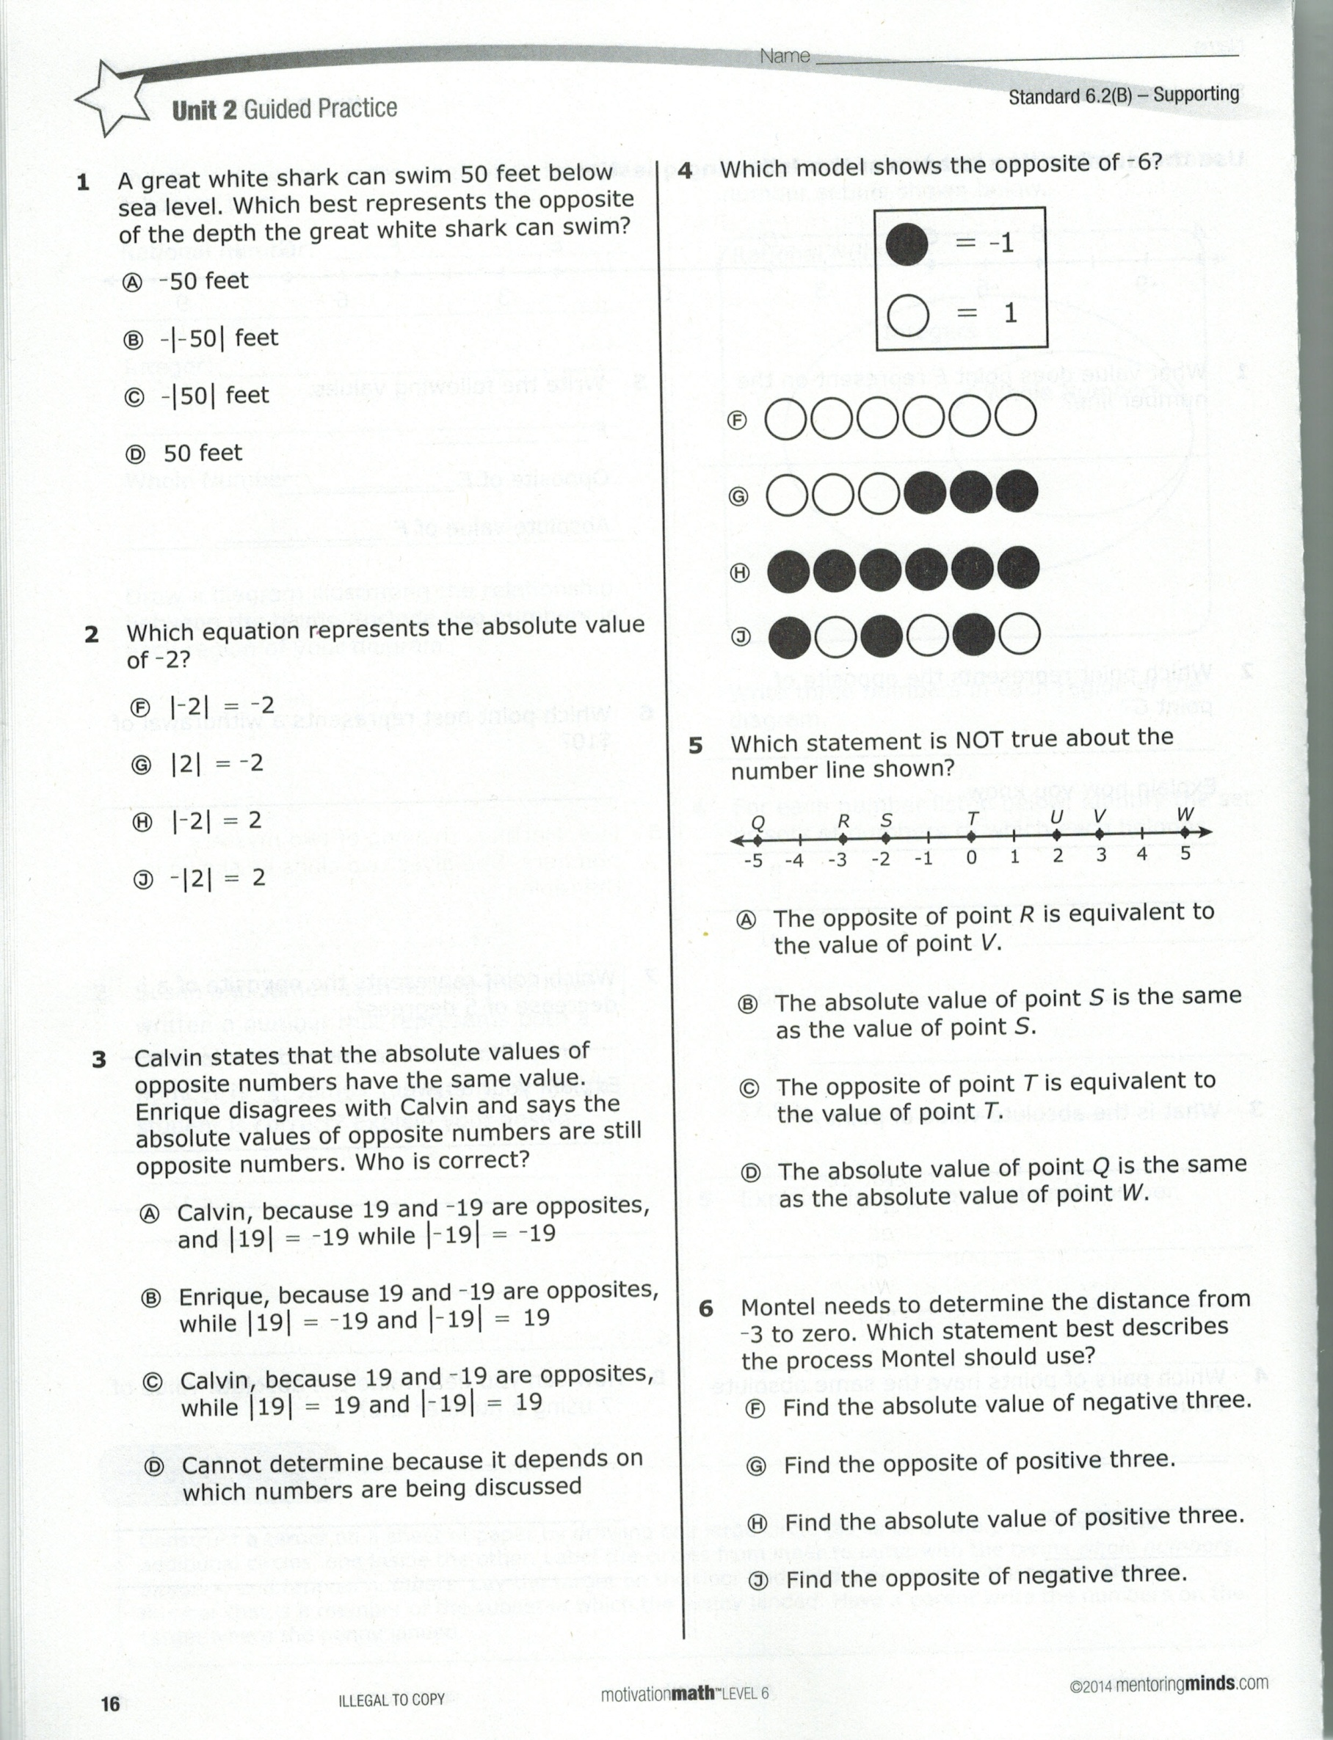

A. Point U is opposite of point R.

B. The absolute value of point Q is equivalent to the value of point W*.*

C. The origin of the number line is at point S*.*

D. The absolute value of point *V* is the same as the absolute value of *T.*

**7.** Label the points with the appropriate letter.

A(-2, -9) B(3,-3) C(-9,2) D(-8,-5)

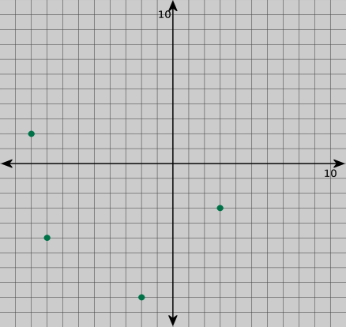

**8.** What integer is the opposite of the value of point *S* on the number line?



**9.** Arrange the following numbers in order from least to greatest.

7.2, 72, $\frac{15}{2}$, 72%

**10.** What point is opposite point E across the x-axis?

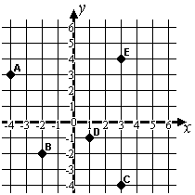

**11.** Using the coordinate grid above, name the ordered pair for point B.

**12.** List the rational numbers in descending order.

$\frac{3}{5}$, 60% , .65 , 0 , -1 $\frac{3}{4}$

**13.** Tabitha borrowed $10 from her brother. Write an integer to represent Tabitha’s transaction.

**14.** It was 5 below zero in Alaska. Which integer below represents the temperature in Alaska?

A**.** 5° B. 50° C. -5° D. 50°

**15.** Write an integer problem to represent the movement on the number line.

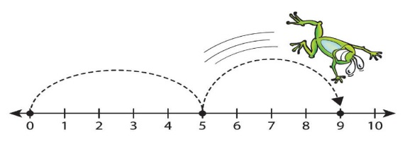

**16.** Draw arrows on the number line below to represent 8 + (-5)

http://www.mathatube.com/images/number-line.gif

**Find the sum for problems 17 and 19**

**17.** -26 + 14

**18.** -9 + -5

**19.** 65 + -29

**20.** **Mt. Everest, the highest elevation in Asia, is 29,028 feet above sea level. The Dead Sea, the lowest elevation, is 1,312 feet below sea level. What is the difference between these two elevations? Use the UPS Check strategy in the space below to solve the problem.**