**Homework Sheet # 4M** Name:

Parent Signature: Date: Period:

*Show all work* - ***NO CALCULATORS! Due: Thursday 9/25***

**_______________________________________________________________________**

**1.** Place the rational numbers in the appropriate boxes in accordance to the relationship of the numbers.

-6, $\frac{1}{3}$, 0, 2.5, 8

Rational Numbers

Integers

Whole Numbers

**2.** Circle the following numbers that are integers?

8, 1.22, -16, $\frac{9}{3}$, 0

**3.** What is the absolute value of -25?

**4.** Find the sum of -7 + 8

**5.** Which statement is true about the number line shown?

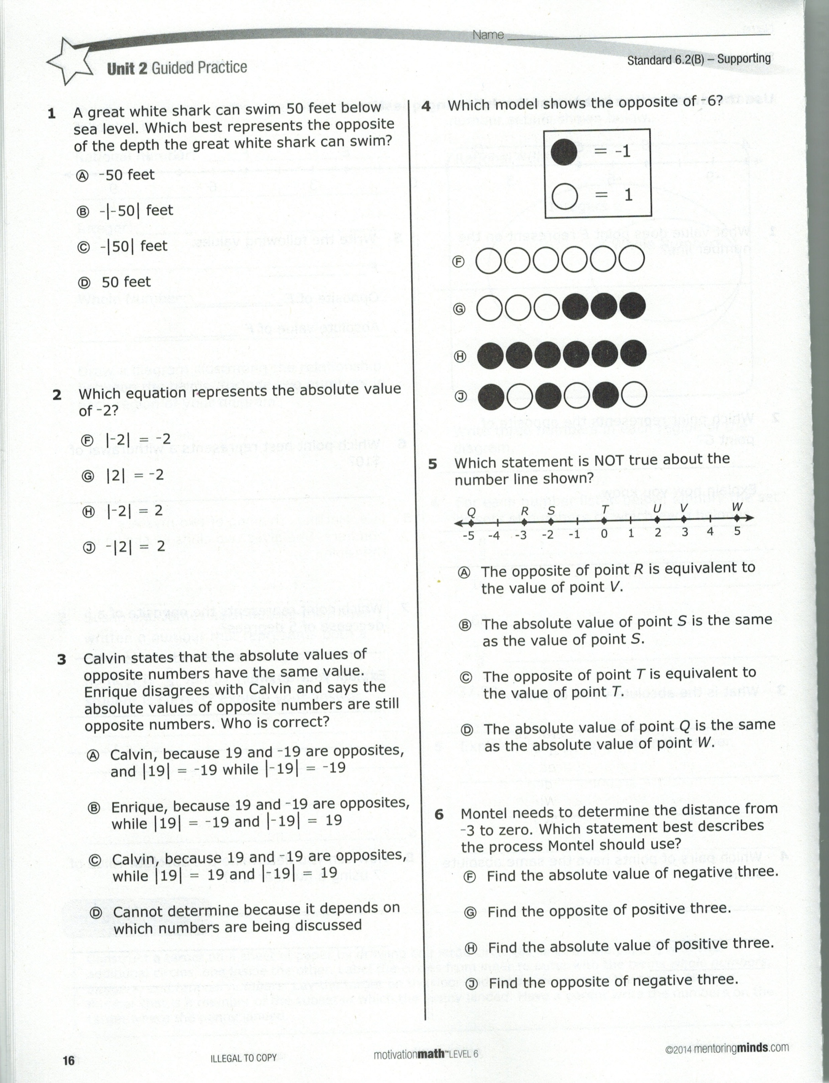

A. Point U is opposite of point R.

B. The absolute value of point Q is equivalent to the value of point W*.*

C. The origin of the number line is at point S*.*

**7.** Label the points with the appropriate letter.

A(-2, -9) B(3,-3) C(-9,2) D(-8,-5)

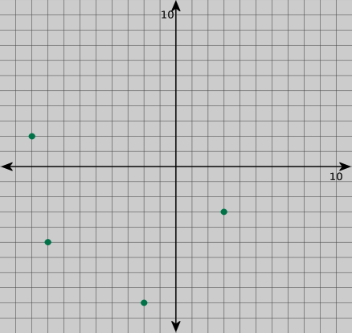

**8.** What integer is the opposite of the value of point *S* on the number line?



**9.** Arrange the following numbers in order from least to greatest.

7.2, 72, $\frac{15}{2}$, 72%

**10.** What point is opposite point E across the x-axis?

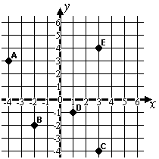

**11.** Using the coordinate grid above, name the ordered pair for point B.

**12.** List the rational numbers in **descending** order. (Hint: G to L)

$\frac{3}{5}$, 60% , .65 , 0 , -1 $\frac{3}{4}$

**13.** Tabitha borrowed $10 from her brother. Write an integer to represent Tabitha’s transaction.

**14.** It was 5 below zero in Alaska. Which integer below represents the temperature in Alaska?

A**.** 5° B. 50° C. -5°

**Find the sum for problems 15 and 16**

**15.** -26 + 14

**16.** -9 + -5